Dorothea Lange
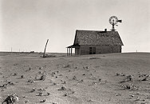
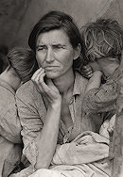
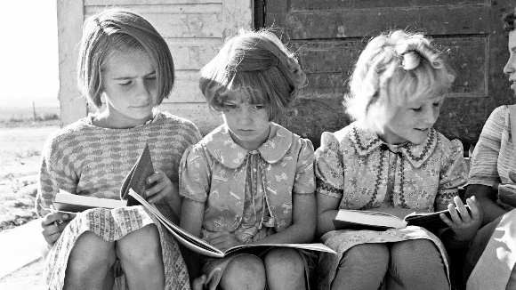
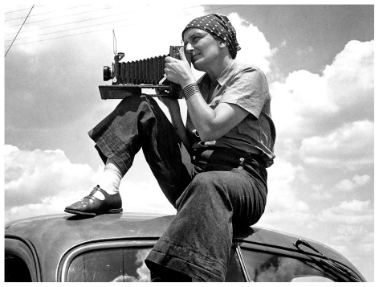
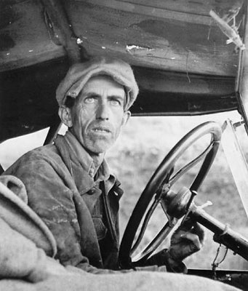

Dorothea Lange lived through May 26, 1895, to October 11, 1965 she has been called America's greatest documentary photographer because of her well stories of the Great Depression and for her photographs of migratory farm workers. Portraits of displaced farmers during the Great Depression greatly influenced later documentary photography. During the Great Depression, Dorothea Lange photographed the unemployed men who wandered the streets. During the Great Depression, Dorothea Lange photographed the unemployed men who wandered the streets. She also included captions with words themselves. Art and literature were important when she was growing up her parents were both strong advocates for her education, and exposure to creative works filled her childhood. After High school although never showed much interest in academics went to the New York Training School for Teachers in 1913.She then decided to pursue a career in photography after a stint working in a NYC photo studio. She then went on to study the art form at Columbia University. Then over the next years started working for several different photographers. In 1918 she was running a successful portrait studio and lived in San Francisco with her husband and two sons. She first started documentary photography in the 1920s when she traveled around the Southwest with Dixon, mostly photographing Native Americans. Then in the 1930’s started focusing on the things around her in San Francisco this shifted her main focus to the great depression. Over the next years she started traveling and documenting the rural hardship she encountered for the Farm Security Administration, established by the U.S. Agriculture Department. That is where she photographed her most well-known portrait migrant mother and many more that gently and beautifully captured the hardship and pain of what so many Americans were experiencing. In her final years she was hired by the Office of War Information (OWI) to photograph the internment of Japanese Americans. In 1945, she was employed again by the Owl again this time to document the San Francisco conference that created the United Nations. She co-founded Aperture, a small publishing house that produces a periodical and high-end photography books. She took on assignments for Life magazine, traveling through Utah, Ireland and Death Valley. She also accompanied her husband on his work-related assignments in Pakistan, Korea and Vietnam, among other places, documenting what she saw along the way. Then sadly, she passed away from esophageal cancer in October 1965.

Edward Sheriff Curtis

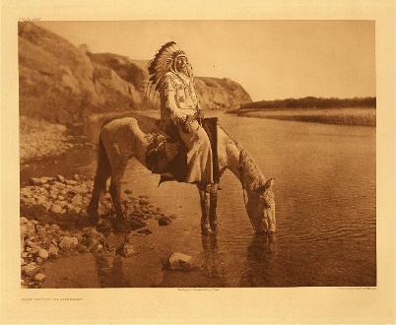
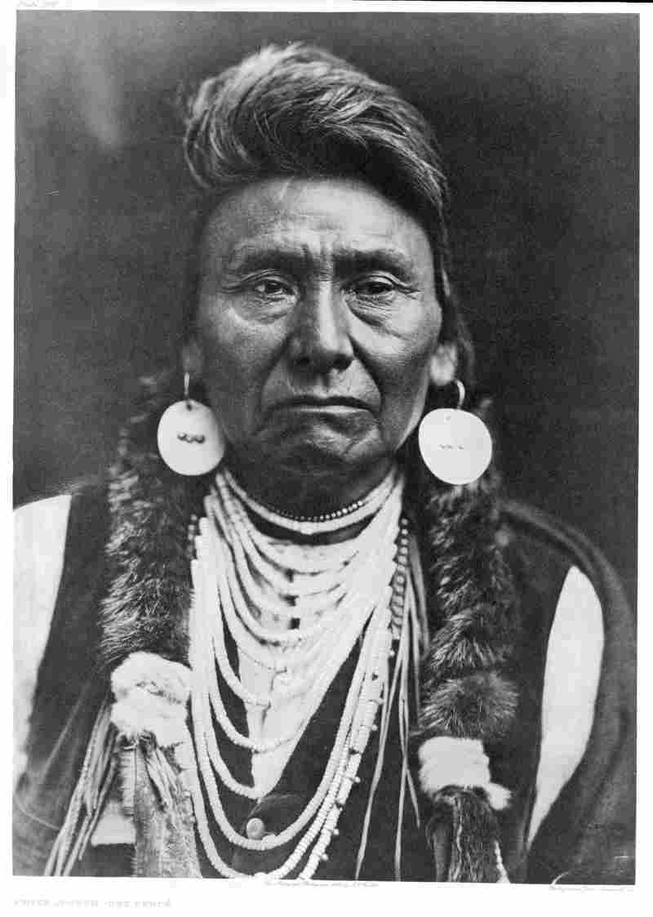
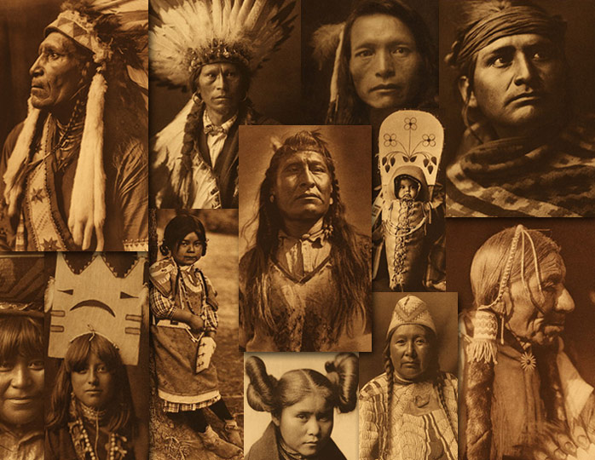

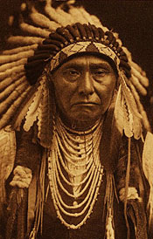
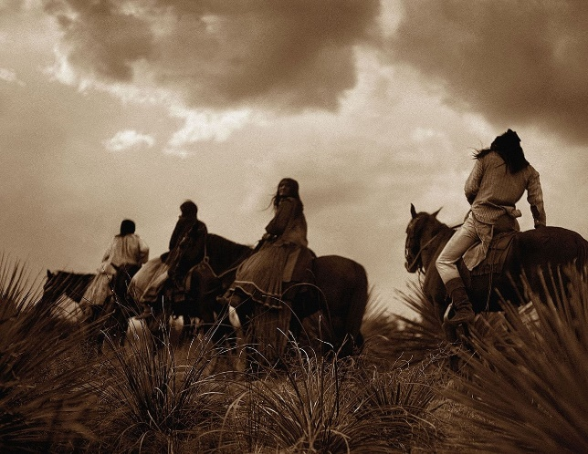

Edward Sheriff Curtis, or the “Shadow Catcher” as he was later called was born Feb 16, 1868 near Whitewater, Wisconsin. His father, a Civil War veteran and a Reverend, moved the family to Minnesota, where Edward became interested in photography and soon constructed his own camera. When he was 17 years old he became an apprentice photographer When the family moved near Seattle, Washington he bought a second camera and bought a half interest in a photographic studio. He married and the couple had four children. In 1898 while photographing on Mt. Rainier, Curtis encountered a group of prominent scientists who were lost, among them George Bird Grinnell, a noted Indian expert, who became interested in Curtis’ work and invited him to photograph the Blackfeet Indian people in Montana two years later. He then started to take interest and focus on methodology and Indian Tribes. Over the next years he, although struggled made arrangements to go to visit the tribes. Once on site Curtis and his assistants would start work by interviewed the people and then photographing them One of his major goals was to record as much of the people’s way of traditional life as possible. Guided by this concept, Curtis made 10,000 wax cylinder recordings of Indian language and music. In addition he took over 40,000 images from over 80 tribes and recorded many more traditions and customs. But sadly in 1930, the years of struggle finally took their toll with Curtis suffering a physical and nervous breakdown he slowly started to decline and passed away on October 21, 1952 at the age of 84 but the native beauty, strength, pride, honor, dignity and other admirable characteristics will always be remembered in his work.

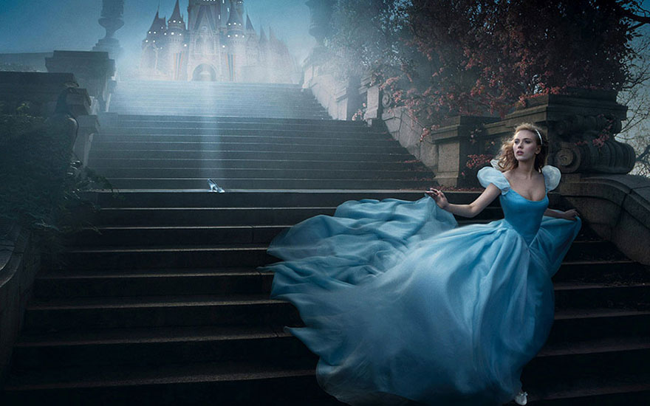
Annie Leibovitz

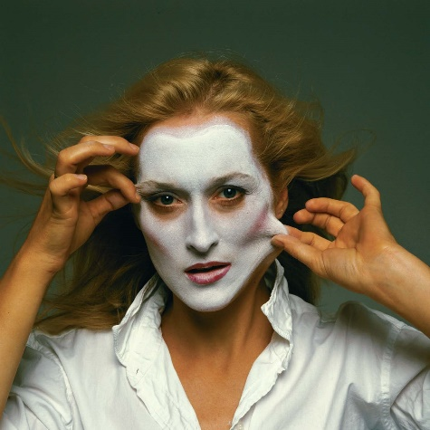

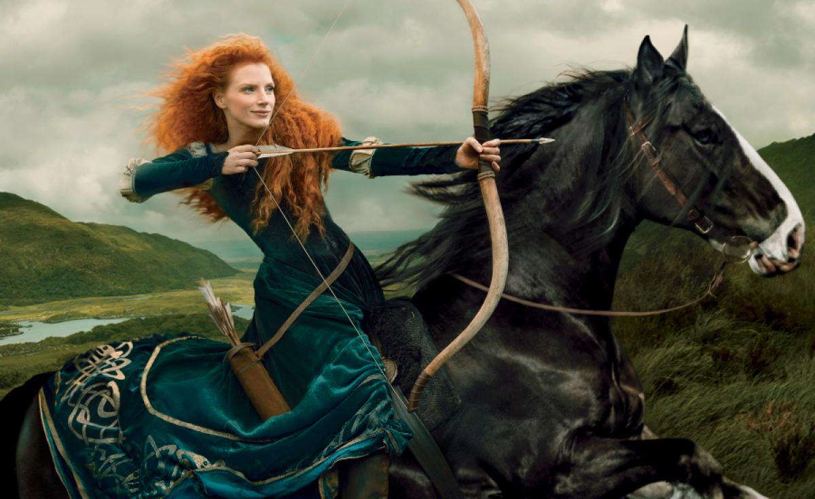

Annie Leibovitz was born on October 2, 1949, in Waterbury, Connecticut. In 1967 while although studying painting at the San Francisco Art Institute, she developed a love for photography and started taking night classes, and in 1970 got a job for the Rolling Stones magazine and became the chief photographer in 1973. While working for Rolling Stones she developed her trademark technique, which was using bold primary colors and surprising poses. In 1983 she left Rolling Stones and started working for Vanity Fair. Leibovitz has created several award-winning advertising campaigns one of them was for American Express, for which her portraits of celebrity cardholders won her a 1987 Clio Award. In 1991, Leibovitz’s collection of more than 200 photographs were exhibited at the National Portrait Gallery in Washington, D.C. She was the first woman to be so honored. Her books include Annie Leibovitz: Photographs (1983), Photographs: Annie Leibovitz 1970–1990 (1991), Olympic Portraits (1996), Women (1999), American Music (2003), A Photographer’s Life: 1990–2005 (2006), Annie Leibovitz at Work (2008), Pilgrimage (2011), and Annie Leibovit. Exhibitions of her photographs have appeared at museums and galleries all over the world, including the National Portrait Gallery and the Smithsonian American Art Museum in Washington, D.C.; the International Center of Photography in New York; the Brooklyn Museum; the Stedelijk Museum in Amsterdam; the Maison Européenne de la Photographie in Paris; the National Portrait Gallery in London; and the Hermitage Museum in St. Petersburg, Russia. She is widely considered one of America’s best portrait photographers and continues to be in demand as a photographer.

